
HELLENIC REPUBLIC
MINISTRY OF SHIPPING & INSULAR POLICY
SHIPS INSPECTION GENERAL DIRECTORATE
DIRECTORATE FOR THE VERIFICATION OF SAFETY
AND SECURITY MANAGEMENT OF SHIPS AND PORT FACILITIES
Address : 150, Gr. Lampraki str.
Post Code : 185 18, Piraeus, GREECE
E-mail : dedaple@hcg.gr

Maritime Labour Convention (MLC), 2006

Annual Report

Inspection Activities
01 January 2016 to 31 December 2016

Contents

 | Page
Purpose | 03
System of Inspection | 03
Ships Inspected | 03
Violations of Legislation, Penalties Imposed and Cases of detention of Ships | 06
Conclusion | 06

Purpose

This report is prepared in accordance with Standard A5.1.4.13, taking into consideration the guidance provided in B5.1.4.10 of the Maritime Labour Convention, 2006 (MLC) Code and covers the period from 01 January 2016 to 31 December 2016. The statistics contained in this report take into account only ships to which are required to be certified according MLC, 2006.

System of Inspection

The following categories of ships have to be inspected and certified in accordance with the requirements of the convention and maintain a valid Maritime Labour Certificate (ML Certificate) and the Declaration of Maritime Labour Compliance (DMLC) Parts I and II issued:

i. Ships of 500 gross tonnage or over, engaged in international voyages;
ii. Ships of 500 gross tonnage or over, operating from a port, or between ports, in
another country; and
iii. Other ships, as may be voluntarily requested by a shipowner.

The circulars that are applicable are:
- Ship certification according MLC (MLC01) and\
- Certification of Declaration of Maritime Labour Compliance (DMLC Part II) (MLC02)
The total number of authorized MLC inspectors/auditors by Hellenic Administration is 48.
The Administration after taking into account the requirements set out for authorization of recognized organizations in Standard A5.1.2.1, has authorized RO’s to conduct maritime labour verification inspections and certification of Hellenic flag ships. A shipowner has the option to choose the certification body between the flag and the authorized RO. The number of appointed RO’s inspectors during 2016 is 1546.

Ships Inspected

The following is a record of inspections for issuance of ML certificates carried out on Hellenic registered ships, during the period of this report.

Number of ships inspected by Hellenic Administration | 8
Number of ships inspected by authorized RO’s | 390
Total number of ships inspected | 398
Number of ships with no deficiencies | 376
Number of ships with deficiencies | 22
Total number of deficiencies | 24

The total number of deficiencies noted during inspections for certification is broken down by category as follows:

Reg 1.1 | Minimum Age | 0
Reg 1.2 | Medical Certificates | 4
Reg 1.3 | Training and Qualifications | 1
Reg 1.4 | Seafarers recruitment and placement services | 1
Reg 2.1 | Seafarers employment agreements | 5
Reg 2.2 | Payment of wages | 1
Reg 2.3 | Hours of work and hours of rest | 3
Reg 2.5 | Repatriation | 1
Reg 2.7 | Manning levels | 1
Reg 2.8 | Career and skill development and opportunities for seafarers’ employment | 0
Reg 3.1 | Accommodation and recreational facilities | 1
Reg 3.2 | Food and catering | 2
Reg 4.1 | Medical care on board ship and ashore | 0
Reg 4.3 | Health and safety protection and accident prevention | 0
Reg 5.1.2 | Authorization of A.O. | 1
Reg 5.1.3 | Maritime labour certificate and declaration of maritime labour compliance | 1
Reg 5.1.5 | On-board complaint handling procedures | 1
Reg 5.5 | Chief officer | 1

Table 1: Deficiency categories.
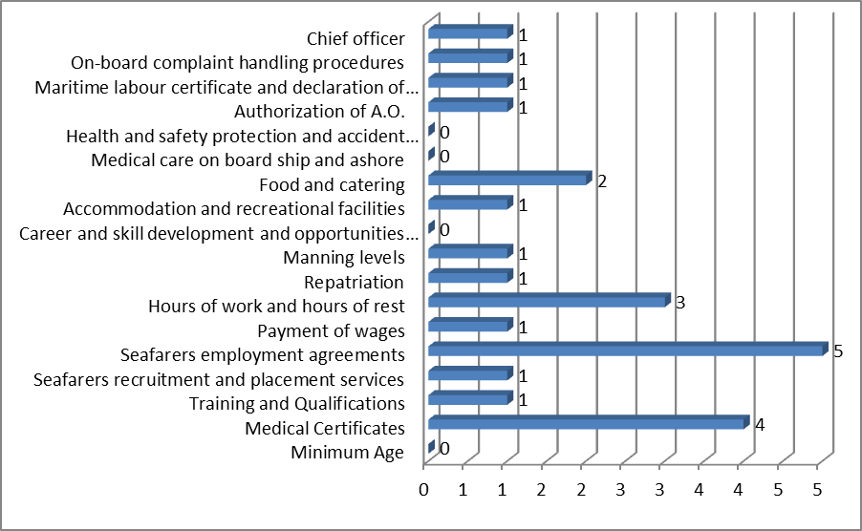
Figure 1: Deficiency categories
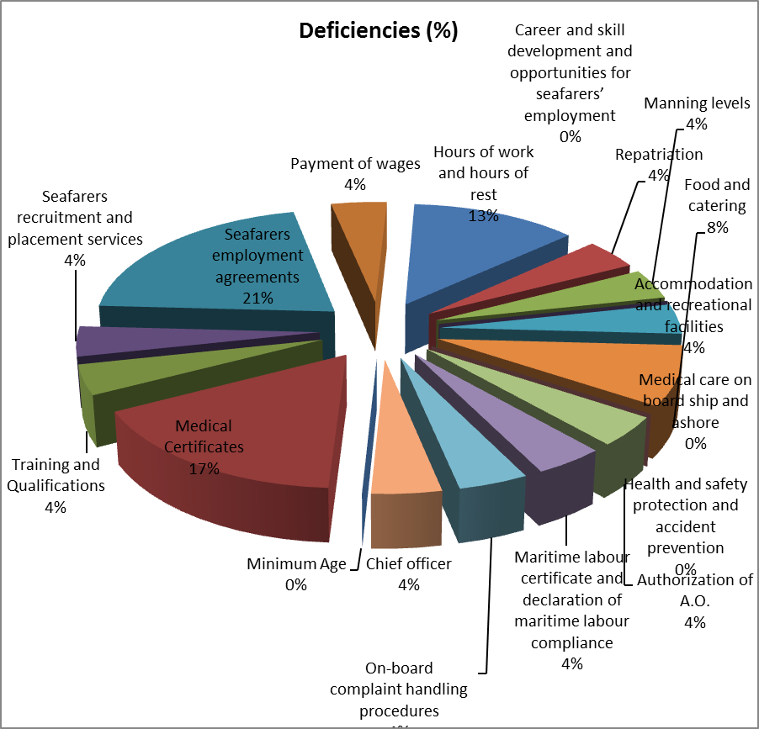
Violations of Legislation, Penalties Imposed and Cases of detention of Ships

Violation of legislation and penalties imposed
During the period of this report there was evidence of violation of legislation.
Ships Detention
During the period of this report, there was one (01) Hellenic registered ship detained on MLC related items.

Conclusion

1. The report has been prepared to provide an accurate account of the implementation of MLC on board certified ships during the period 01 January 2016 through 31 December 2016.
2. In comparison with last annual report (2015), we consider that there is a decrease in the average number of deficiencies which indicates a better familiarization with Maritime Labor Convention, 2006.
4. The aim of the Hellenic Administration is to maintain the high level of compliance with the MLC requirements on board Hellenic flagged ship that has accomplished throughout the year 2016.

* * * * *

